**ITCS 209 Object Oriented Programming**

Assignment Week 2 (Due 28 January 2019)

Name: _____________________Section: ____ ID: ____________

Instructions:

* Assignment must be uploaded to the My Courses system <https://mycourses.ict.mahidol.ac.th> by due date
* For questions that need to write a program, you also need to zip all the code files, rename the zip file to your student id, and upload it to the My Courses system.

**Exercise 1**: Explain the difference between an object and a class. And give an example of objects and classes.

**Answer**

A class is what creates and defines objects, or a group or category of similar objects. Object is a physical thing.

If there is a class called “animal”, the objects in this class could be a dog, a cat, a bird, a fish, etc.

**Exercise 2:** What’s wrong with the following program?

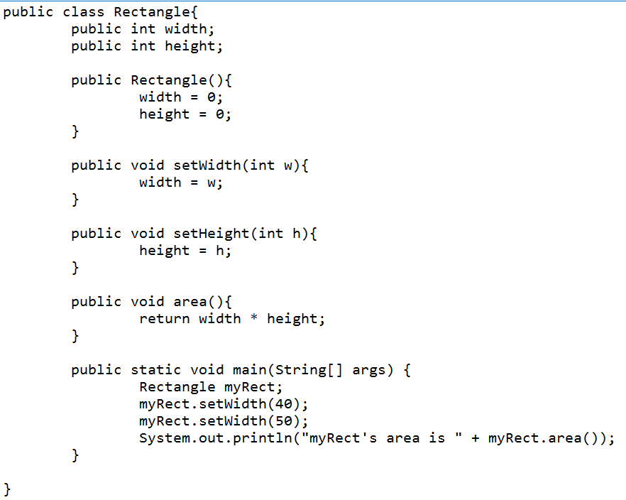

**Answer.** *(Hint there are two problems in this code)*

1. “public void area()” should not have “return” value.
2. “myRect” has not been initialized.

**Exercise 3:** Fix the Rectangle program shown in Exercise 2, and show the output of this program.

**Answer** (please show your output here)

1. “public void area()” 🡪 “public int area()”
2. “Rectangle myRect;” 🡪“Rectangle myRect = new Rectangle();”

Output:

myRect's area is 0

**Exercise 4.** BankAccount Class is provided below.

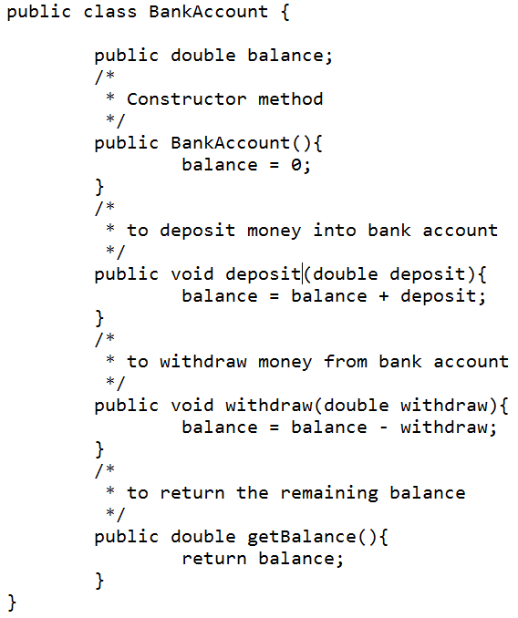

Write a BankAccountTester class whose main method constructs a bank account, deposits $1,000, withdraws $500, withdraws another $400, and then prints the remaining balance. Submit your source code and show the output of your program here.

public class BankAccountTester {

public static void main(String[] args) {

BankAccount account1 = new BankAccount();

account1.deposit(1000);

account1.withdraw(500);

account1.withdraw(400);

System.out.println(account1.getBalance());

}

}

Output:

100.0